4. Substrate can bind to the active site of enzymes and form weak interactions (hydrogen bonds, ion bonds etc.) with amino acid residues. These interactions can stabilize the structure of enzyme so that thermal denaturation of hexokinase was ratardid in the presence of one of its substrates.

7. (b) (e) (g)

8.

(a)

[s]=0.0017M

(b) $V_{0}=\frac{k_{cat}{[E]}_{t}{×1/2K}_{m}}{K_{m}+{1/2K}_{m}}=1/3V_{max}$

$V_{0}=\frac{k_{cat}{[E]}_{t}{×2K}_{m}}{K_{m}+2K_{m}}=2/3V_{max}$

$V_{0}=\frac{k_{cat}{[E]}_{t}{×10K}_{m}}{K_{m}+{10K}_{m}}={10}/{11}V_{max}$

(c) The red curve corresponds to enzyme B and the back curve correspond to enzyme A.

11.

(a) $k_{cat}=\frac{V_{max}}{{\left[E\right]}_{t}}=\frac{1.6μM s^{-1}}{4nM}=400 s^{-1}$

(b) $V_{0}=\frac{k_{cat}{[E]}_{t}[HAPPY]}{K_{m}+[HAPPY]}$ $300 nM s^{-1}=\frac{400 s^{-1}×1 nM×30μM}{K_{m}+30μM}$ $K_{m}=10μM$

(c) 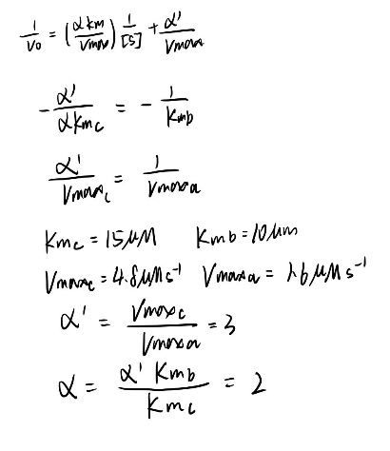

(d) For α=2 and α΄=3 neither of them equal to 1, ANGER is mixed inhibitor.

13.

14. (a)

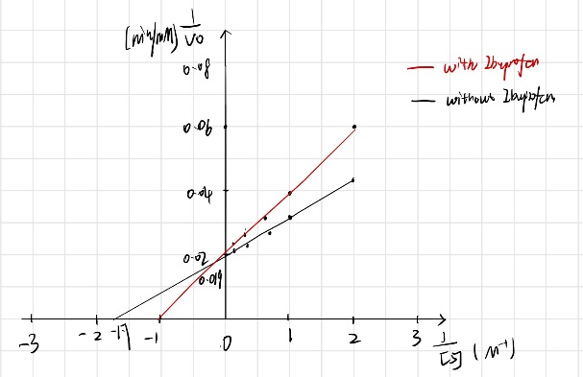

(b) From the curve with inhibitor, we can determine that Km increased, whereas Vmax doesn’t have significant change. So, ibuprofen is competitive inhibitor.